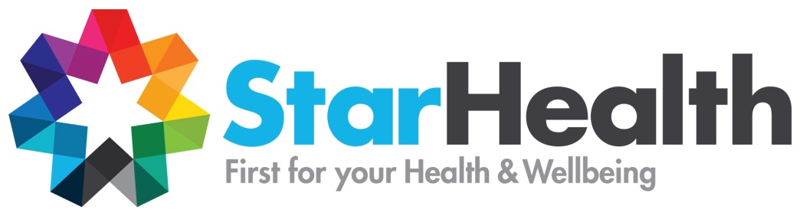

Indigenous Women’s & Family Support Worker

0.6EFT - Fixed Term Position

Job Reference No: VAC0484

- Flexibility of working days/hours
- Access to learning and development opportunities
- 2 types of Salary Packaging Available

An opportunity has become available to work and support Aboriginal and Torres Strait Islander women and families in the local Inner South area of Melbourne. This role will engage with the local Indigenous community, in particular women and families to improve their overall health and wellbeing, strengthen cultural identity and relationships with family and community.

To be suitable for the role you will possess the following:

- Be of Aboriginal and/or Torres Strait Islander background
- This is an identified Indigenous position (must state in CV/Cover Letter)
- Have a good understanding of Aboriginal and Torres Strait Islander cultures and society
- Proven ability to work with high needs client groups – particularly women and families
- Have good time management skills
- Preferably previous experience in a similar role
- Ability to work effectively with specialist and mainstream health and welfare services
- Have an existing Victorian Drivers Licence
Who We Are
Star Health works in partnership with people and communities to promote and improve equity, health and wellbeing by delivering innovative client-directed services that take into account the context of the individual and the community, and championing prevention and change to address the structural reasons for health inequity.

Applicants must complete our application form directly via our website http://www.starhealth.org.au/careers/current-vacancies/ For further information about the role, please contact Alison Craigie-Parsons on 03 9525 1300 or email: ACraigie-Parsons@starhealth.org.au
Closing Date: Friday 24th August 2018 @ 5pm

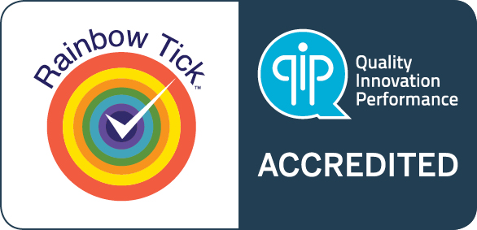
Star Health is an equal opportunity employer and encourages people with disabilities and individuals of diverse backgrounds including those from the Aboriginal and Torres Strait Islander, Culturally and Linguistically Diverse and LGBTI+ communities to apply.

